Week 2
🔰 Beginning

I further developed the basic knowledge of networking acquired in Week 1 at the onset of Week 2. The emphasis was put on the manual configuration of IP addresses with the help of Linux command line and system configuration files like /etc/network/interfaces.

I was not accustomed to editing system files and working with such commands as nano, ifdown, and ifup. Also, I was not much exposed to using networking commands such as ping to check the connection.

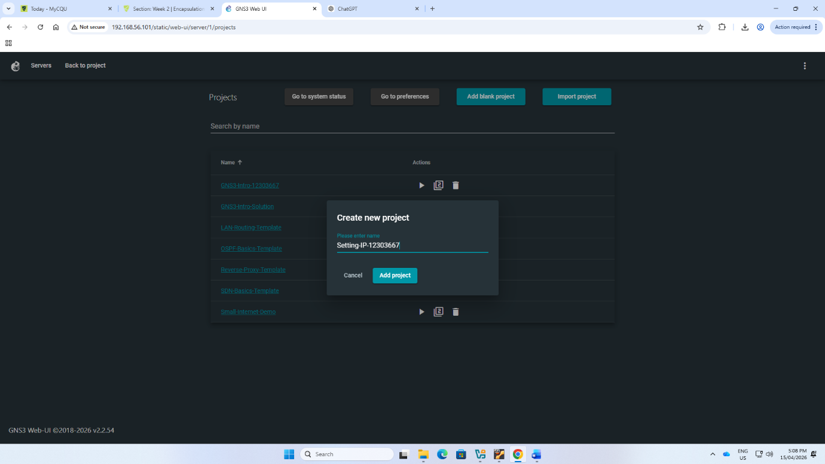
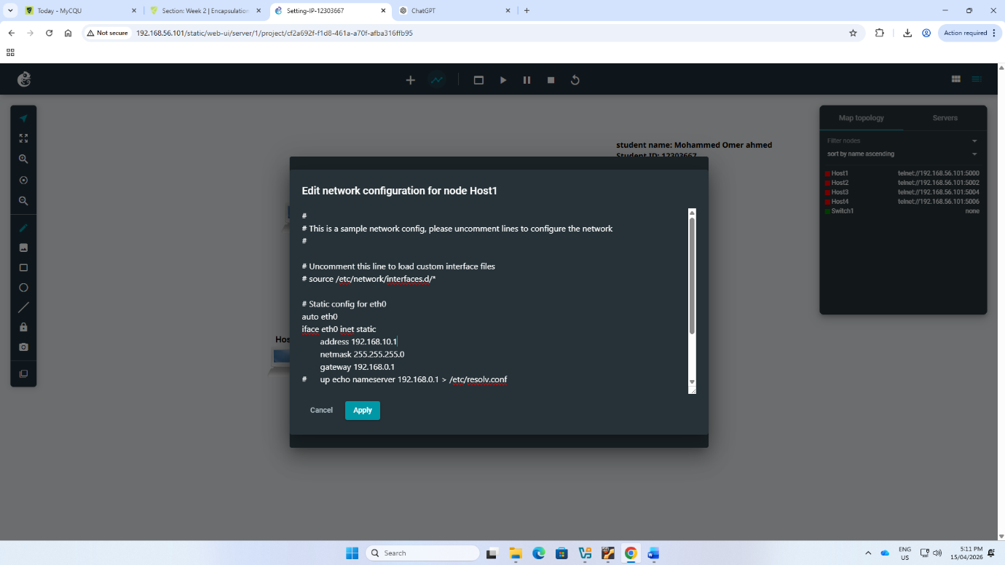
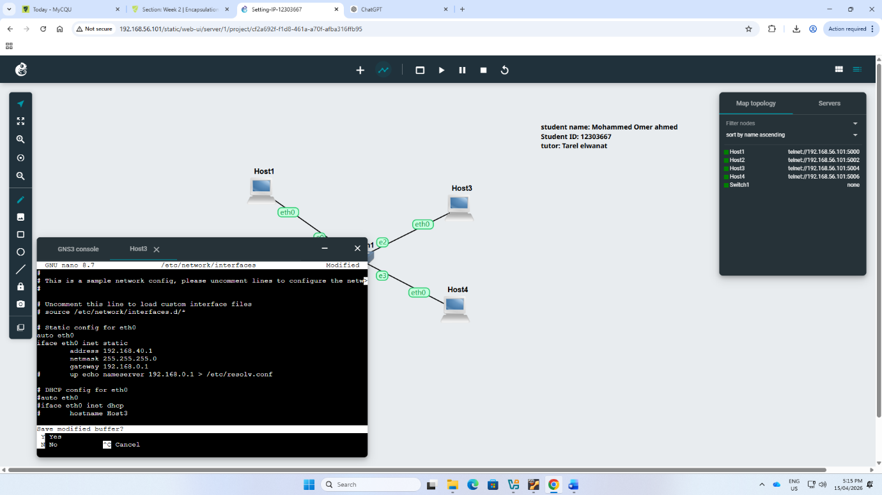
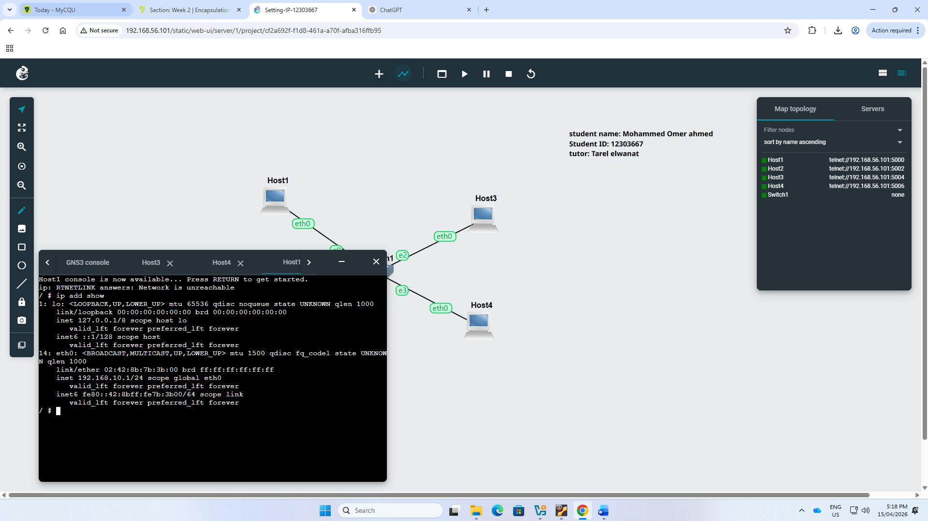
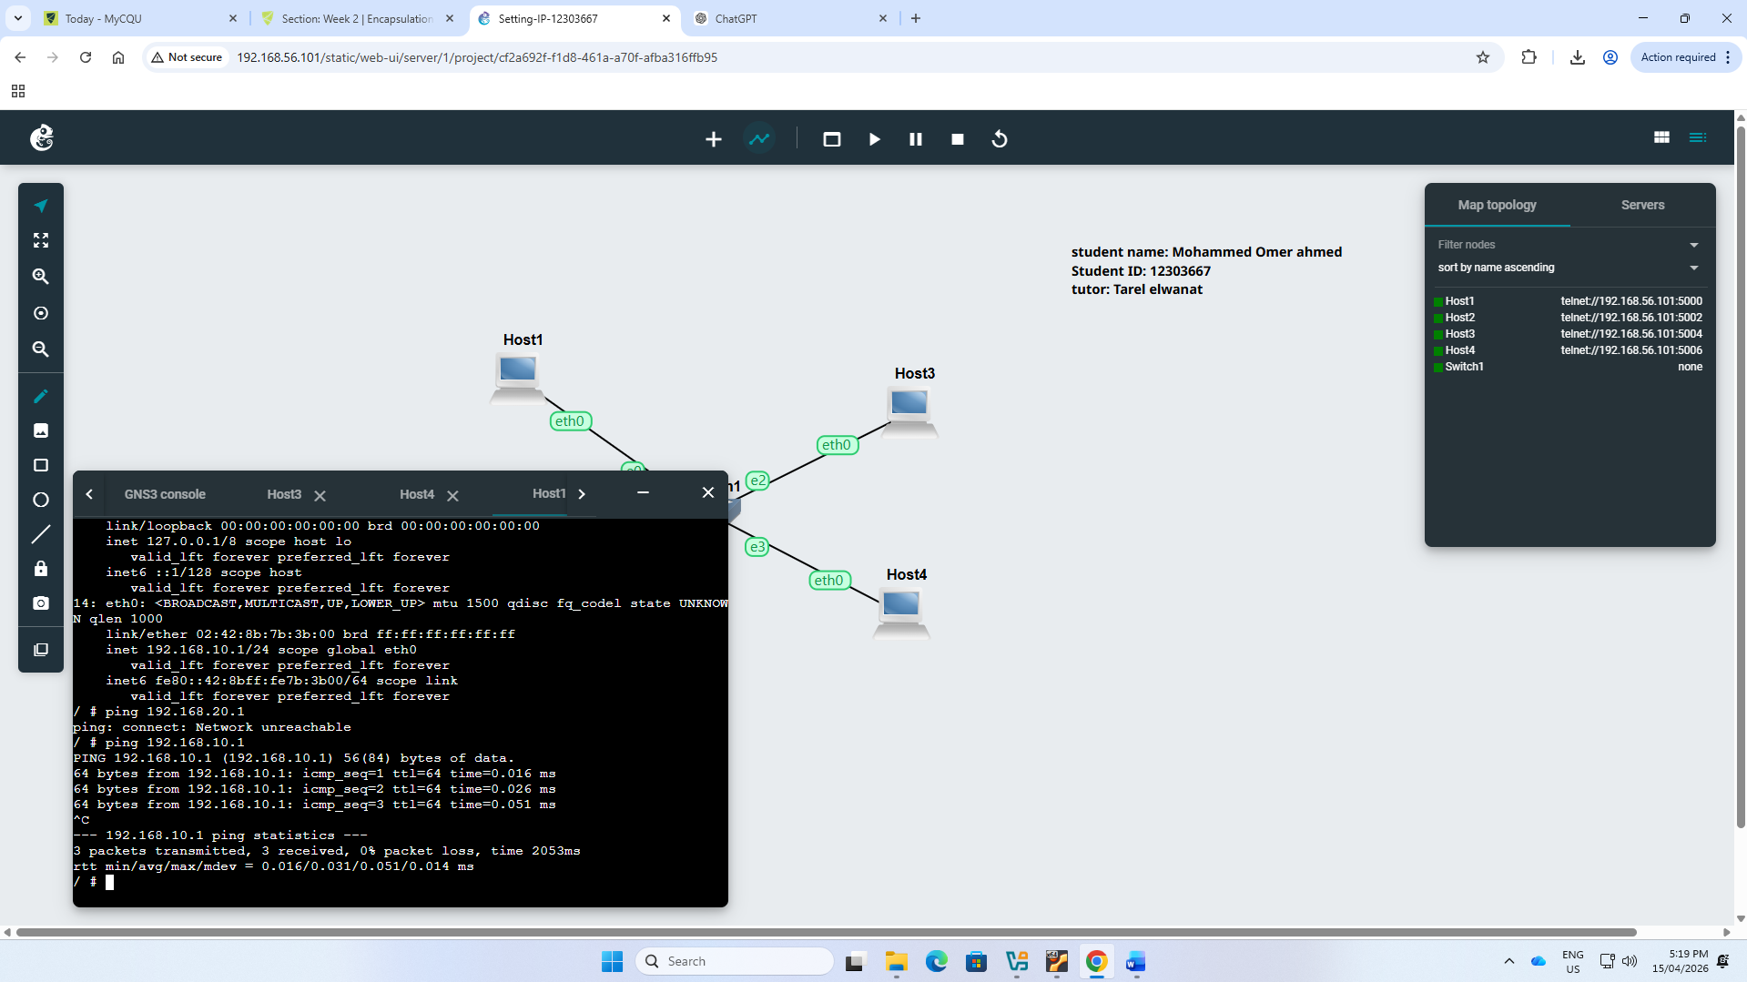
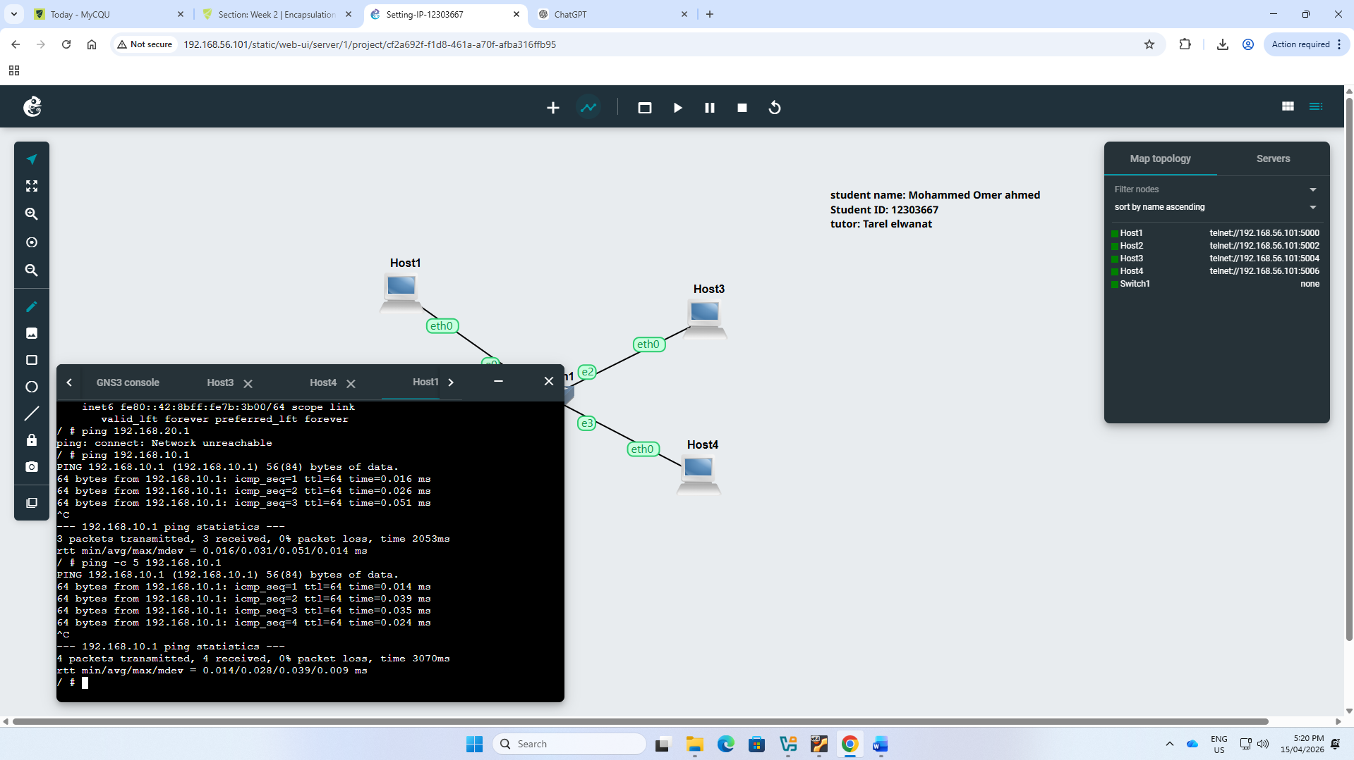
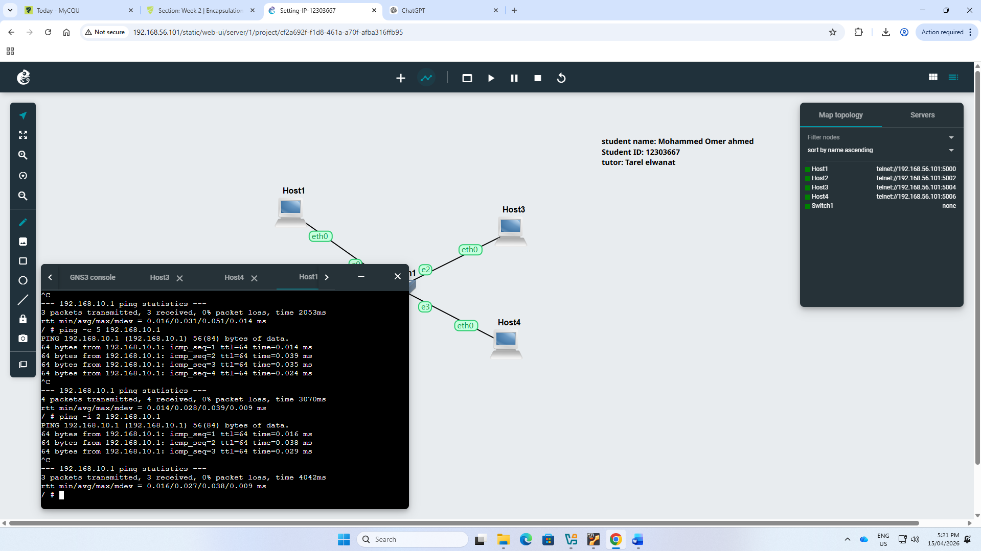
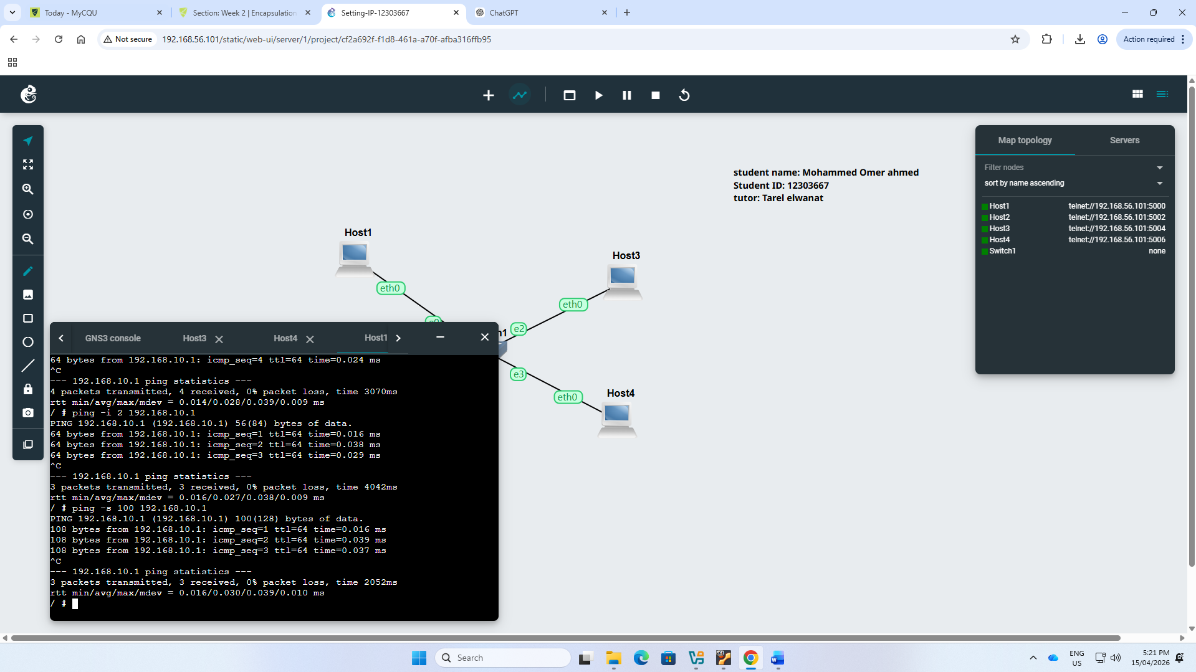
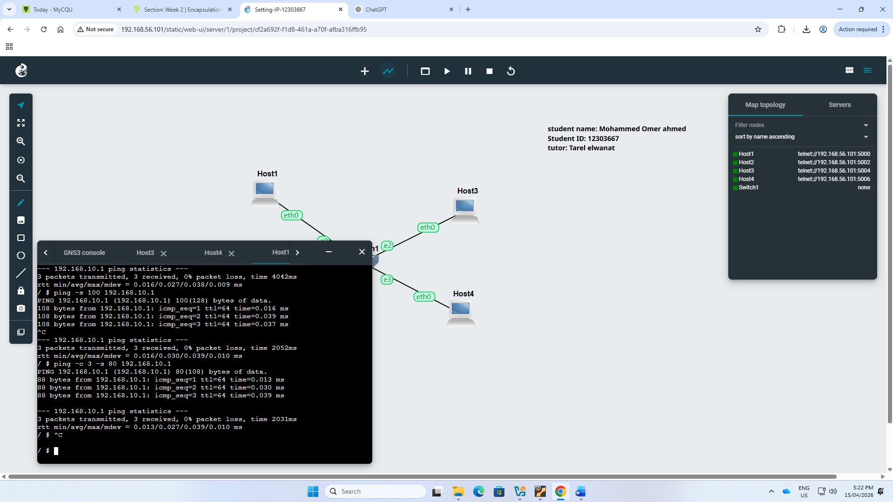
🔁 Reflection

At the conclusion of Week 2, I managed to set up the static IP addresses with three different tools: the GNS3 interface, the editing of the /etc/network/interfaces file, and the ip command. I knew the distinctions between temporary and permanent configurations.

I also got to know how to use the ping command to check the network connectivity and round-trip time (RTT). I could read ping replies, such as packet loss and delays. These hands-on activities enhanced my problem-solving abilities and provided me with a better insight into the operation of networks.

